**Practical 1A: HTML Hands-on (Font Formatting Tags)**

**Aim:** To demonstrate font formatting tags

**Question:** Design a webpage for your college using font formatting tags for your departmental fest Xenith

**Concepts:**

|  |  |  |
| --- | --- | --- |
| **Tag** | **Purpose** | **Where It Was Used** |
| <abbr> | Abbreviations with tooltip explanations | IT-Dept, TIFR, IIT, DSP, Fort, Mumbai, data professionals |
| <q> | Short inline quotations | “We take ourselves very seriously”, talk titles |
| <strong> | Strong importance/emphasis (visually bold) | Xenith, Day 1, second and final day, Xenith'20 |
| <em> | Emphasis (screen reader stress + italics) | much appreciation, highly interesting |
| <cite> | Titles of cited works (talks, events, exhibitions) | A Glitch in Time, Bot the Builder, Enliten IT India, Laser Tag Event |
| <kbd> | Keyboard input | Ctrl + Enter |
| <samp> | Sample output from programs | df.describe() |
| <code> | Inline code | Pandas |
| <var> | Variable/placeholder-style content | logic, creativity, teamwork |
| <address> | People/organization contact info (typically authors) | Dr. Rajendra Shinde, Dr. Paritosh K. Pandya, Mr. Aashish Sharma, etc. |
| <mark> | Highlighted content | Xenith, huge success |
| <small> | Auxiliary/small print text | Version info, notes |
| <del> | Deleted (outdated) content | <del>2022</del> replaced year |
| <ins> | Inserted (revised) content | <ins>2024</ins> inserted year |
| <sub> | Subscript | <sub>final</sub> |
| <sup> | Superscript | <sup>*</sup> |

**Code:**

index.html

<!DOCTYPE html>

<html>

  <head>

    <title>Practical 1A</title>

  </head>

  <body>

    <h1>Welcome to <mark>Xenith</mark>!</h1>

    <p>This is a fest conducted by the <abbr title="Information Technology">IT-Dept</abbr>.</p>

    <p><q><em>We take ourselves very seriously.</em></q></p>

    <br>

    <p><strong>Xenith</strong> is a department festival celebrated once in two years.</p>

    <p>

      The theme for <strong>Xenith 2020</strong> was <q>Glitches to Perfection</q> and was scheduled for

      17 and 18 January. During the two days, several events were organized.

    </p>

    <p>

      Xenith 2020 marked its beginning by inaugurating the exhibition titled <cite>A Glitch in Time</cite>

      by respectable Principal <address>Dr. Rajendra Shinde</address>. An exhibition showcasing the project work

      of the students was open to everyone for the entire day.

    </p>

    <p>

      The projects displayed included: <kbd>A Dancing Robot</kbd>, <kbd>Unity-based games</kbd>,

      <kbd>a model Rocket</kbd>, <kbd>gesture recognition sensors</kbd>, <kbd>a 3D printer</kbd> and much more.

      It was received with <em>much appreciation</em> from students as well as teachers from the entire college.

    </p>

    <p>

      The first talk of the fest was conducted by <address>Dr. Paritosh K. Pandya</address>,

      an Indian Computer Scientist and a Researcher at <abbr title="Tata Institute of Fundamental Research">TIFR</abbr>,

      on the topic <q>Intelligent Processing of Indian Music: where technology meets music</q>.

      This <em>highly interesting</em> and well-received session witnessed a discussion about applying

      <abbr title="Digital Signal Processing">DSP</abbr> and computational learning techniques to Indian classical music.

    </p>

    <p>

      Succeeding this, Xenith was honoured to have <address>Dr. Subhasis Chaudhuri</address>, the

      director of <abbr title="Indian Institute of Technology">IIT Bombay</abbr>, for his talk on

      <q>Higher Education: the perspective of an Administrator</q>. It gave a broader and better

      perspective on pursuing higher studies as a college graduate and attracted an audience in large numbers.

    </p>

    <p>

      Apart from these educational and insightful talks, <strong>Day 1</strong> also included innovative and

      challenging events. One such event was <cite>Bot The Builder</cite>, a gameshow-style competition designed

      to test <var>logic</var>, <var>creativity</var>, and <var>teamwork</var>. Teams of two metaphorically built

      robots by solving clues and completing tasks.

    </p>

    <p>

      A <cite>Treasure Hunt</cite> named <q>Glitch Don't Hitch</q> was also organized for people with wanderlust.

      Participants had to face physical tasks and solve mind-boggling clues about <abbr title="Fort locality in Mumbai">Fort, Mumbai</abbr>.

    </p>

    <p>

      The <strong>second and final day</strong> of Xenith included the much-awaited and thrilling

      <cite>Laser Tag Event</cite>. This event was a <mark>huge success</mark> on campus and saw great participation.

    </p>

    <p>

      A workshop was conducted by <cite>GreyAtom</cite> titled <q>Kung Fu Data With Pandas!</q>, which

      introduced the use of <code>Pandas</code> — a high-performance, easy-to-use data analysis tool in

      Python used by <abbr title="Data Scientists and Analysts">data professionals</abbr> for cleaning,

      pre-processing, and extracting insights from data. Participants even tried <samp>df.describe()</samp> and <kbd>Ctrl + Enter</kbd> to run notebook cells.

    </p>

    <p>

      The final talk of Xenith was <q>Mapping Perfection: A Journey Through 3 Case Studies</q> by

      <address>Mr. Aashish Sharma</address>, Co-Founder of <cite>Enliten IT India</cite>. The session covered his

      entrepreneurial journey using three real-world case studies that aligned with the theme of

      <q>Glitches to Perfection</q>.

    </p>

    <p>

      The two-day event concluded with the distribution of certificates and prizes to all participants

      and volunteers by <address>Prof. Rachana Pandey</address>, Staff-In-Charge of <strong>Xenith'20</strong>,

      followed by a congratulatory note from <address>Mr. Chirag Jain</address> (student of TYIT), the Chairperson of Xenith'20.

    </p>

    <p><small>Note: The next edition of Xenith is expected in <del>2022</del> <ins>2024</ins>.</small></p>

    <p><small>Project version: v1.2<sub>final</sub><sup>*</sup></small></p>

    <img src="logo.png"/>

  </body>

</html>

**Output:**

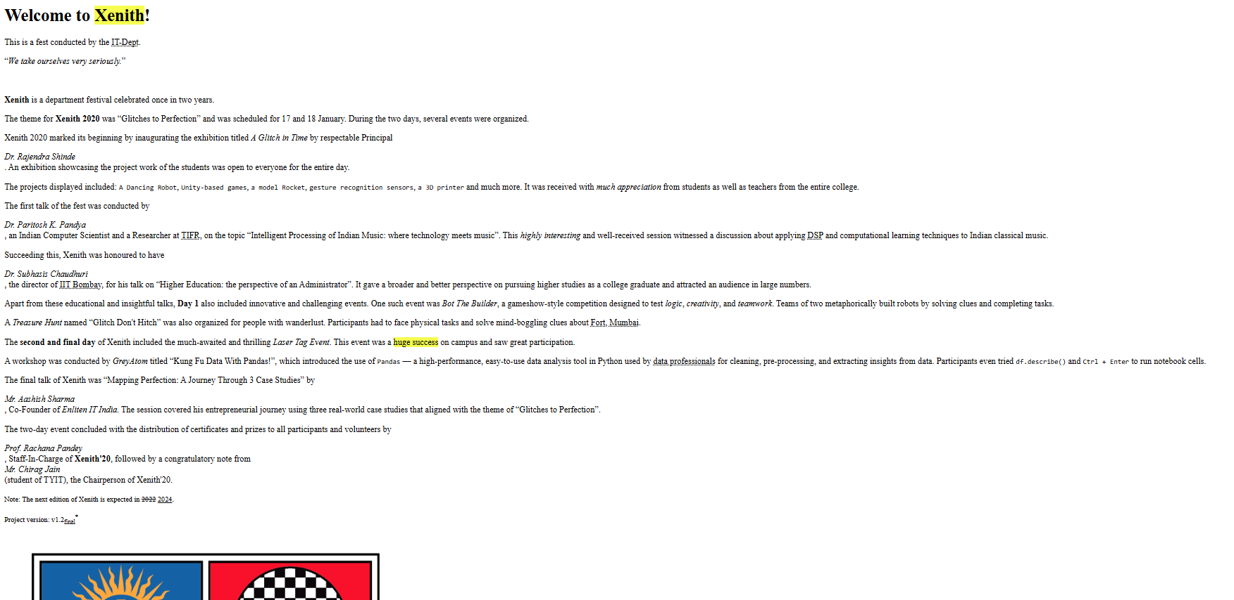

**Conclusion:**

In this document the use of formatting tags can be seen. Different formatting tags such as font formatting and phrase formatting were used. Font formatting tags like <b> <i> <strong> <em> can be used to increase the semantic meaning. Phrase formatting like <code> <samp> <kbd> can be used to display technical or niche details like code or keyboard input.